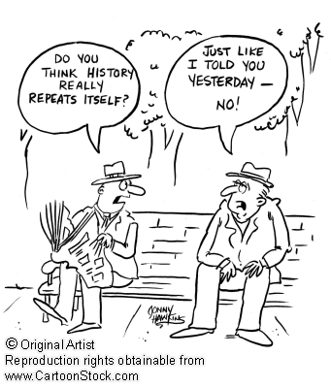
World History Syllabus
Aynor Middle School-Grade 7 2015-2016
Jennifer Wilson
Email Address: jwilson002@horrycountyschools.net
Sign up for Remind101 Updates: Text @7pwh
To: 81010
Website Address: http://amsworldhistory7.weebly.com
Materials needed:
- Students need a 3-ring binder in order to keep notes and other material.
- Paper
- Pencils
- Ear buds
- School issued iPad

Course objective /Standards:
The 7th grade Social Studies curriculum takes students from the time of early exploration to the present. (Last year, the 6th grade curriculum began with at study of ancient history and stopped with the after of exploration, around the 1500s-1600s.) There are 6 standards, or topics that are addressed throughout the year. They are:
- 7-1: European Exploration & Expansion-This unit examines why Europeans decided to explore and expand far beyond their borders and when and where this took place.
- 7-2: Limited and Unlimited Government in Europe-This unit discussed the move from governments with absolute power to the beginning of a limited type of government instituting the idea of self-rule and constitutions.
- 7-3: The Age of Independence Movements and Imperialism-Includes industrial and political revolutions that occurred as early as the 1500s and changed the world dramatically.
- 7-4: World Conflicts-This unit goes further into effects of imperialism and deals with major economic and political upheavals such as World War I, the Great Depression and World War II.
- 7-5: International Developments during the Cold War Era-This unit discusses how the Cold War affected the world politically, socially, and economically.
- 7-6: Major Changes and Challenges of the 20th Century and Beyond-This unit examines the political, economic, geographic, cultural, scientific, and technological advancements that have taken place throughout the world during the past 100 years.
Course standards may be accessed though the following website:
https://ed.sc.gov/agency/se/Instructional-Practices-and-Evaluations/documents/FINALAPPROVEDSSStandardsAugust182011.pdf
Grades/Assessments
The students will be graded using the following guidelines:
- Major Assessments/Assignments: 50%
- Mid-level Assessments/Assignments: 30%
- Daily Assessments/Assignments: 20%
Grading Scale
100-93=A 92-85=B 84-77=C 76-70=D Below 70=F
Make-Up Work
A student who misses any assignment is expected to make up the assignment the day he/she returns. Incomplete work must be completed within 5 days unless Administrative approval is given. Make up work is work that students missed due to being absent from class. This work should be completed and submitted within 5 days.
If you are absent, make up work will be located in the baskets at the front of the room by the specific period.
It is the students’ responsibility to request and complete all missed assignments. Electronic work is required to fill out an electronic make-up sheet.
Late Work Policy:
Students are expected to submit work on the due date. If work is not turned in when it is due after 5 schools days, the work will not be accepted.

Behavior Consequences
1st Offense: Warning
2nd Offense: Lunch Detention
3rd Offense: Parent Contact
4th Offense: Team Meeting
5th Offense: Referral to Administration
*If the degree of student disruption is severe, the student will be removed from the room immediately and may be issued a referral.*

Google classroom group to join: Period :_____________ group code:___________________

